The Queensland Water Directorate (qldwater) is a membership organisation providing a voice for all Queensland public water and sewerage service providers. The water and sewerage industry in Queensland is complex and depending where you live, these services can be provided by your local Council, a Distribution and Retail Entity (DRE) or a State-owned corporation. Our core members include Councils (including Wide Bay Water Corporation), both DREs (Unitywater and Queensland Urban Utilities) and the Gladstone Area Water Board.
Water and sewerage services play an important role in our health and wellbeing and are regulated by a number of Government Departments, most notably the Department of Energy and Water Supply (DEWS) the Department of Health, Department of Infrastructure, Local Government and Planning, and Department of Environment and Heritage Protection.
DEWS recently introduced a new way to track the performance of water and sewerage service providers (SPs) through 65 Key Performance Indicators (KPIs). The results will be publicly available, giving communities an overview of the general state of their water and sewerage infrastructure and services including water security, financial status, customer engagement and environmental performance. Initially the results will be presented as raw data, but over time, service providers, government agencies or other interested parties will start publishing more community-friendly and readable materials. This fact sheet attempts to help deal with that start-up phase, when things remain a little confusing. It should also be noted up-front that this is the first time that this data has been collected for many SPs, and there is some information that is being collected for the first time for all SPs. It will take some time to ensure that everything is collected in a consistent way.
There are a wide range of ‘external’ factors which can influence a SP’s performance, for example:
Climate | Geography | Size | Asset Age
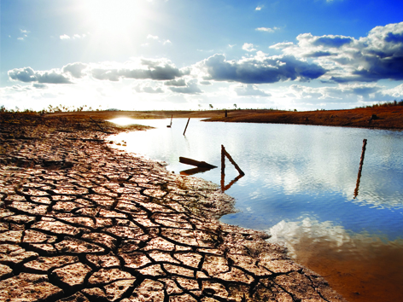 | 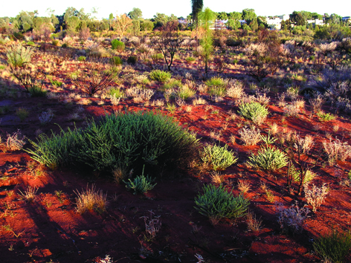 |  | 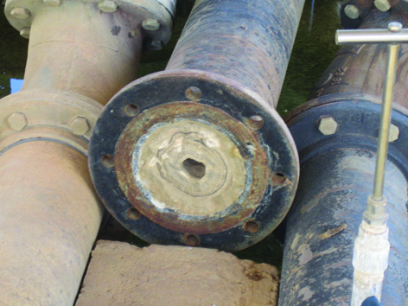
Rainfall patterns, evaporation and temperature. | Geology (the type of soil) and topography of your region. | Size does matter! The number of people connected and the size of the area being serviced all play a role. | Old assets may require more maintenance/repairs and be less efficient.
Location | Services Provided | Water Source | Regulation
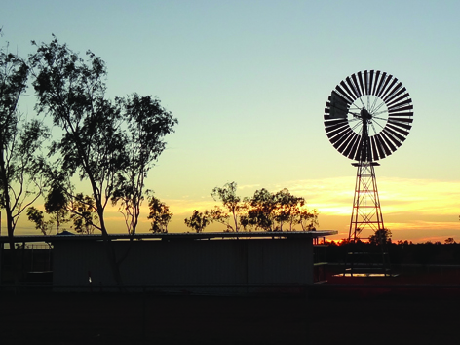 | 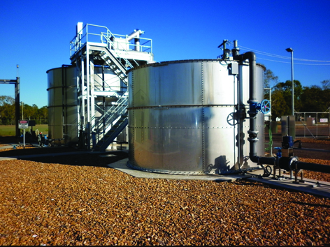 | 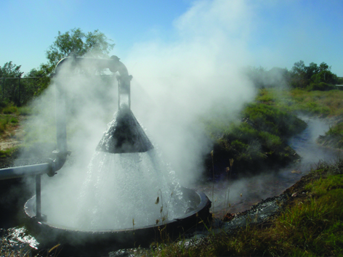 | 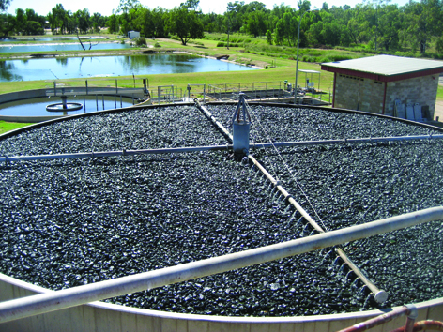
Queensland is a big state with communities ranging from urban cities and towns to rural, semi rural and remote. | Is your water treated or is treated water imported from other suppliers? | Water from a river, dam or bore may require different treatment. Distance to supply affects pumping and infrastructure costs. | SPs need to achieve strict water quality standards through water and sewage treatment.
This fact sheet provides more information about the KPI data that is captured, highlights the inconsistencies that could arise from comparisons and offers possible explanations if some of the data raises questions. Indicators are divided into six series including General, Water Security, Finance, Customers, Environment and Other.

Series 1 – General
These indicators provide an overview of the infrastructure including water and sewerage mains, treatment plants, water storage, water sources, connected properties and volume of water sourced and supplied.
Q: Why is our maximum daily demand so high?
A: High demand can be climate-related with more water used for gardening and in many towns for evaporative air conditioning during dry and hot periods. Hot and dry regions will have more water use than other regions.
Q: What is non-revenue water?
A: Water that is produced but not directly paid for by a customer. Examples are leaks, fire fighting use, process water (e.g. water used for backwashing during treatment or cleaning mains) and “stolen” water through illegal connections.
Q: Does my SP employ the right number of water and sewerage people?
A: Organisation size, asset age, location (urban vs remote), services provided, water source and regulation all influence how many staff are needed to efficiently and safely run the water and sewerage network. In some councils, roles are shared and some staff may provide water and sewerage services as well as fill other roles in the council. This is a new indicator being collected for the first time, and we expect there to be significant differences in the way some SPs have calculated their numbers.

Series 2 – Water Security
Water security indicators include months of water supply remaining, capacity to meet future demand, available contingency supplies and information on water restrictions if applicable.
Q: Why is our supply so low when we have such high rainfall?
A: Water security is complex and storage levels depend on catchment structures, climate patterns, time of year and amount of catchment runoff. Reporting this value ‘as at 30 June’ means that it refers to the dry season when water supplies are often at their lowest. Many regions with high rainfall only have a small storage capacity at any particular point in time meaning communities must use water wisely regardless of rain.
Q: Why does my SP report ‘no water restrictions’ when we are on permanent water restrictions?
A: Permanent water restrictions are classed as permanent water conservation measures by the government for the purposes of this reporting.
Q: Why are we on water restrictions when it is the wet season?
A: In some places treated water is stored in reservoirs or other facilities and the capacity of these holding tanks can affect restrictions even after high rainfall events. Many regions with high rainfall only have a small storage capacity at any particular point in time meaning communities must use water wisely regardless of rain.

Series 3 – Finance
These indicators help SPs plan for the future and gauge efficiency and include capital expenditure, replacement costs, revenue, operating and maintenance costs, depreciation and forecast expenditure for the next five years.
Q: Why is our capital expenditure so high?
A: The water infrastructure across Queensland is ageing while in many places it has to service a growing population. Quite often SPs need to invest in better technology to meet increased environmental demands or spend big money to provide certainty of supply. This can appear as spikes on a chart as big capital investments can vary greatly from year to year and depending on grants received and any upgrades that are underway.
Q: Why are our maintenance and operating costs so high?
A: There are a range of reasons. One important factor is the type of fresh water source which determines the level of treatment. Surface waters like rivers require more expensive treatment than deep bores. Generally, older pipes require more maintenance or repairs. Older treatment plants are typically less automated and require more attention to operate. Towns that are very spread-out will cost more to service than those that are more densely populated. Sewage treatment costs are driven by the environmental values and legal requirements in each specific area. Highly treated sewage is better for the environment but expensive to produce due to power and chemical costs.
All of these costs can also be higher for regional and remote SPs because of the costs of procuring and transporting goods and services which are not locally available.
Q: Why is the financial data provided for the KPI framework different to that published elsewhere?
A: Financial data is audited every year by SPs but the timing of this varies and small changes may be recorded after data has been submitted for the KPI framework.

Series 4 – Customer
This series of indicators includes the charges for water and sewerage, typical residential bills, the number of mains breaks and other unplanned interruptions, average response times to incidents and the number of customer complaints. Some include financial information, while others address community service expectations which are published in SP Customer Service Standards or codes.
Q: Why is the average response time so high compared to other SPs?
A: SPs with numerous and/or remote communities often need to cover large distances to respond to an incident and the response time can seem extremely high compared with city utilities. For example, if Council X had only one burst water main incident for the year but they had to travel three hours to reach the location, the average response time for the whole year is displayed as three hours. The response times agreed with the community differs from town to town as defined in the local Customer Service Standards or code, as some communities are prepared to accept longer response times than others. This particular indicator is also new for many SPs – we know that how an “incident” is recorded can be very different and are working to standardize approaches.
Q: The fixed charge for water/sewerage seems extremely high compared to others – why would that be?
A: Fixed charges help to pay for and maintain the network that delivers the water to or remove sewage from your property. If your SP manages a very large network or recently upgraded the mains or treatment plants, this cost may seem larger than usual. In areas like south–east Queensland, SPs also need to purchase bulk water from another provider. The cost for this is set by the Queensland Government and not by individual SPs. There are also other things like topology (slope) and location (distance to treatment/supply) which affect pumping costs, and water source type/quality which impact treatment costs. In some sensitive areas the quality and volume of sewerage discharge is highly regulated and this can result in greater treatment costs.
Pricing is complex and pricing structures for communities may have been set in process many years ago. In the mean time, the costs have changed substantially for many SPs, including how they source grant support for the big expenses, such as, treatment plants. Most SPs are working to improve customer understanding of the relationship between costs and prices, but the detail varies significantly across the state.
Q: The average bill in our region is much higher than the State average – are we being ripped off?
A: It depends, the costs of providing water and sewerage services vary markedly across the state so that two towns can differ greatly. Compare your prices to those of a similar community particularly with regards to water source, rainfall and size to get a better idea of how your bills compare. *Insert a graph here with real diverse examples to explain some of the factors.
Q: Why have there been so many complaints?
A: As a new indicator for many SPs, there will be a significant variation in how this is reported. While a definition for a “complaint” has been provided, what actually gets recorded through call centres and other sources can be variable. The water and sewerage services industry as a whole is working with the regulators to address this.
Q: Why do our pipes/mains burst so often?
A: Pipes/mains burst due to three main causes:
- Old age and/or poor maintenance
- Soil type with highly reactive soils expanding and shrinking more readily which may result in more bursts/leaks.
- Third party direct damage (e.g. excavator digging through a water main).
The data provided does not allow for these causes to be distinguished, so your SP may have reported lots of bursts but it is difficult at this time to tell what the cause was.
Q: Sometimes our water tastes and looks pretty bad – why is that?
A: All SPs must adhere to strict guidelines as set in the Australian Drinking Water Guidelines (ADWG). There are plenty of external factors that play havoc with the taste and appearance of your water, for example your water source. While some schemes are blessed with high quality source water which requires a simple treatment process, others must be carefully treated due to variable seasonal source water quality. It is legal to provide water so long as it meets safety standards and this can still allow some water supplies to be less aesthetically appealing than others. Unappealing flavours, odours and colours that plague some water sources often provide no health risk and some communities even swear by their local drop despite tourists detecting an unusual bouquet. The aesthetic qualities of a water supply can be negotiated with the SP as part of Customer Service Standards but unfortunately additional treatment for some common issues can come at a high cost. However, if you recognize a change in your drinking water, you should certainly contact your SP to enquire of the possible cause.

Series 5 – Environment
Environmental indicators show initiatives taken by SPs to reduce the nutrient / sediment load from source waters and receiving waterways.
Q: Why isn’t my SP doing more towards reducing nutrients and sediments in source/receiving waters?
A: They may well be, but this indicator is only related to some specific surface waterways from which drinking water is sourced or to which treated sewage is discharged. Removing some nutrients totally is prohibitively expensive so treatment of sewage is always a balance between protecting the environment and maintaining affordable sewerage services for the community.

Series 6 – Other
Three other indicators are included in performance reporting, including the operating ratio, capital replenishment ratio and debt to revenue ratio.
Q: Why are these ratios for my SP vastly different from other SPs?
A: These are standard financial ratios, again being reported discretely for water and sewerage services for the first time for many SPs. They represent many factors including how much the SP has had to borrow to provide infrastructure to service its communities. This can reflect historical policies of a council, relative wealth and countless other factors. In essence these indicators provide information on “financial health” but there will be many people looking at the results for some time yet to determine what is “good” or “bad” and in many instances further information will be required to understand what has contributed to these “coarse” values.

Copyright qldwater. This document may be reproduced whole or in part by qldwater members.

